Profile Branch Coding

Issue – Area & Time

Question 1 : What is the main area for YPF

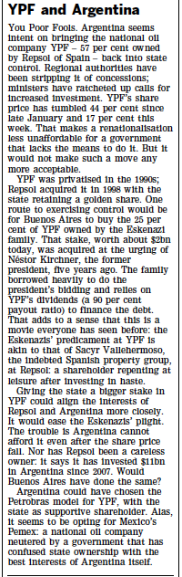

A ) Spain

B ) Argentinia

C ) Other Country

Question 2 : What is the time for Burger King

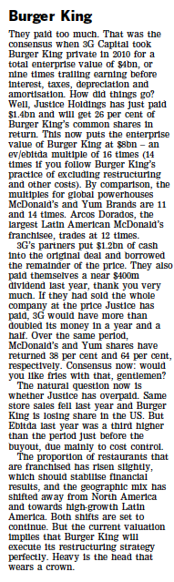

A) Present

B ) Past

C ) Past and present

D ) Future